

# Description of the business organization and the business area chosen



Figure ‑ Logo of Ryak Tires Shop

## Current Business Process

# Use case identified for the current System

### Use case Description for Customer Arrival

|  |  |
| --- | --- |
| Use Case ID | UC_001 |
| Use Case Name | Customer Arrival |
| Actors | Customer, Owner |
| Precondition | The customer arrives at the service center with a requirement. |
| Main Flow | 1. Customer arrives and requests a service. 2. Owner interacts with the customer to understand their needs for tire repair, inspection, or retreading. |
| Alternative Flow | * If the customer’s requirement is unclear, the owner provides additional information or a consultation. |
| Postcondition | Customer’s requirements are identified and documented for further processing. |

Table Use case Description for Customer Arrival

### Use case Description for Create Invoice

|  |  |
| --- | --- |
| Use Case ID | UC_002 |
| Use Case Name | Create Invoice |
| Actors | Owner, Customer |
| Precondition | Customer service requirements are identified. |
| Main Flow | 1. Owner generates an invoice based on the customer’s requested services. 2. The invoice is presented to the customer for review. |
| Alternative Flow | * If the customer requests changes to the services, the owner modifies the invoice accordingly. * If the invoicing system is down, the owner may issue a manual invoice. |
| Postcondition | An invoice is generated and presented to the customer. |

Table Use case Description for Create Invoice

### Use case Description for Process Payment

|  |  |
| --- | --- |
| Use Case ID | UC_003 |
| Use Case Name | Process Payment |
| Actors | Owner, Customer |
| Precondition | An invoice has been created and presented to the customer. |
| Main Flow | 1. Customer reviews the invoice. 2. The owner processes the payment using the chosen payment method. |
| Alternative Flow | * If the customer does not have sufficient funds or the preferred payment is unavailable, the owner discusses alternative options or a payment plan. * If the payment system is down, the owner may accept cash or defer payment until service completion. |
| Postcondition | Payment is successfully processed or recorded for later collection. |

Table Use case Description for Process Payment

### Use case Description for Inspect Tire

|  |  |
| --- | --- |
| Use Case ID | UC_004 |
| Use Case Name | Inspect Tire |
| Actors | Owner, Worker |
| Precondition | Customer has explained their service requirements. |
| Main Flow | Owner or assigned worker inspects the customer’s tire to assess the condition.  The tire’s condition is recorded for further action. |
| Alternative Flow | * If the tire is beyond repair, the owner advises the customer to consider purchasing a new tire. * If additional issues are identified during inspection, the service request may be updated. |
| Postcondition | Tire condition is assessed, and the customer is informed of the recommended service. |

Table Use case Description for Inspect Tire

### Use case Description for Assign the Worker

|  |  |
| --- | --- |
| Use Case ID | UC_005 |
| Use Case Name | Assign the Worker |
| Actors | Owner, Worker |
| Precondition | Tire inspection is complete, and necessary work is identified. |
| Main Flow | 1. Owner assigns a worker to perform the required service (repair or retreading). 2. Worker prepares to begin the assigned service. |
| Alternative Flow | * If no worker is available, the owner may schedule the service for a later time or date. * If the assigned worker does not have the required expertise, the owner assigns a different worker. |
| Postcondition | A skilled worker is assigned, or the service is scheduled for completion. |

Table Use case Description for Assign the Worker

### Use case Description for Service Performed

|  |  |
| --- | --- |
| Use Case ID | UC_006 |
| Use Case Name | Service Performed |
| Actors | Worker |
| Precondition | The worker has been assigned to perform the service. |
| Main Flow | 1. The worker performs the tyre repair or retreading as specified. 2. Once completed, the tyre is prepared for customer pickup. |
| Alternative Flow | * If unexpected issues arise (e.g., parts unavailable), the worker pauses the service and informs the owner. * If equipment malfunctions, the service is rescheduled or transferred to a different worker. |
| Postcondition | Service is completed, and the tire is ready for handover. |

Table Use case Description for Service Performed

### Use case Description to Record the Service Details

|  |  |
| --- | --- |
| Use Case ID | US_007 |
| Use Case Name | Record the Service Details |
| Actors | Owner |
| Precondition | Service has been completed. |
| Main Flow | 1. • The owner records service details, including customer information, type of service, and charges. 2. The service record is saved in the system for future reference. |
| Alternative Flow | * If the record-keeping system is unavailable, the owner records details manually or in a temporary log. * If additional services were provided that were not invoiced, the record is updated, and the customer is notified. |
| Postcondition | Service details are recorded and saved in the system. |

Table Use case Description to Record the Service Details

# Current use case diagram

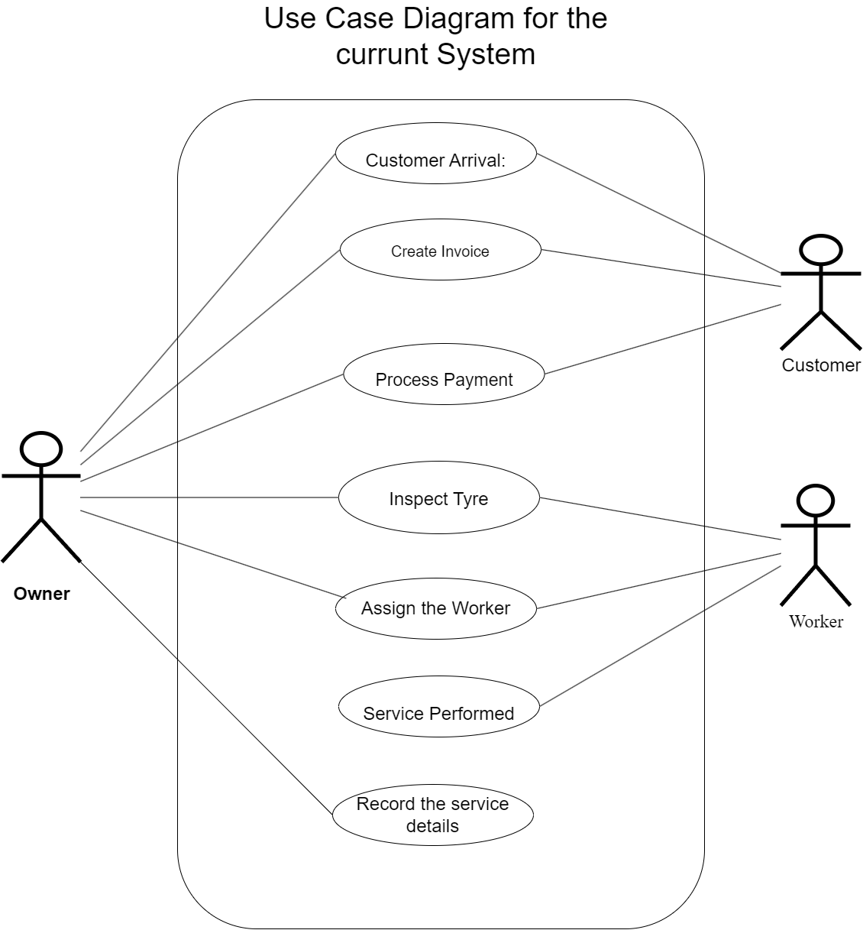

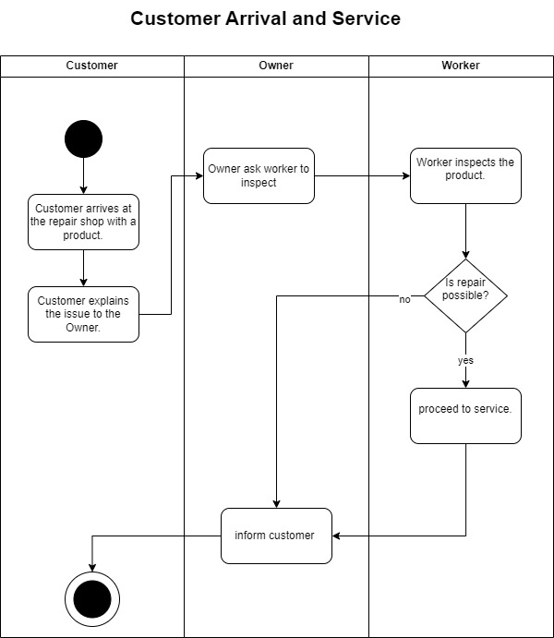

# Current Activity diagram

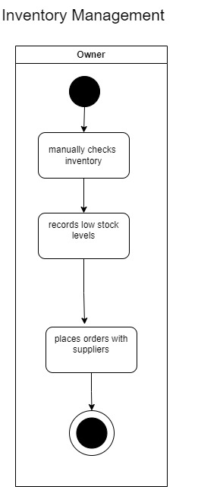

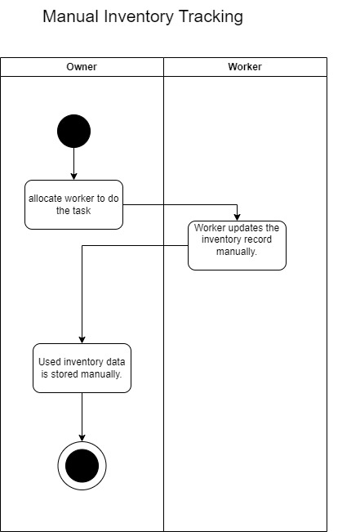

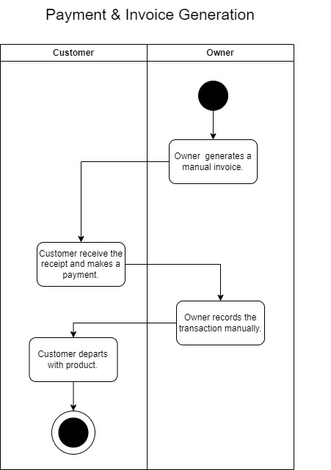

# Functional requirements

* The system **shall** allow new customers to register by entering the required personal information and creating a secure password.
* The system **shall** enable registered users to log in and manage their account information.
* The system **shall** allow registered customers to create new orders by selecting the service type and providing details of the tires.
* The system **shall** enable customers to upload images of the tires when place an order.
* The owner **shall** have the ability to view all newly submitted orders, including uploaded images and selected service types.
* The system **shall** allow the owner to accept or reject each order based on an assessment of the tire's condition.
* If an order is rejected, the system **shall** notify the customer and record the reason for rejection and rejected orders **shall** not be added to the active work queue.
* The system **shall** allow the owner to view each worker’s workload and assign accepted orders accordingly.
* The system **shall** allow the owner to self-assign orders if necessary.
* Assigned workers **shall** be able to update the order status to reflect the current stage of repair.
* The system **shall** provide real-time status updates visible to customers.
* The system **may** allow customers to leave feedback or ratings on completed orders to improve service quality.
* The system **shall** allow customers to view a history of their past orders
* Workers **should** receive a notification when a new order is assigned to them.
* The system **should** notify workers of any pending updates or order assignments.
* Upon completion of repairs, the system **shall** notify the customer that the order is ready for pickup and payment.
* The system **shall** allow the owner to record payment details upon customer payment
* The system **shall** generate a receipt for the completed order and provide a printed copy.
* The customer **should** receive a digital copy of the receipt in their account or via email.

# Non-functional requirements

* The system **shall** have an intuitive and user-friendly interface for the users.
* The system **shall** be mobile-responsive to allow access on various devices, including smartphones and tablets.
* The system **shall** handle multiple users simultaneously without significant delays.
* Status updates, notifications, and payment processing **should** be real time.
* The system **shall** maintain high availability, with minimal downtime
* The system **shall** use encryption to protect customer data, including passwords.
* Role-based access control **shall** be implemented, ensuring sensitive actions (e.g., order assignment, payment updates) are restricted to authorized users.
* The system **shall** validate all data entered by users, ensuring accuracy.

# User stories

|  |  |
| --- | --- |
| Id | User Stories |
| 01 | As a customer, I want to register, create an account and place an order by selecting the service type and uploading images of my tyres, so that the owner can assess them for repair. |
| 02 | As a customer, I want to view the status of my order and be notified when my order is accepted, denied and ready in real, so I can track its progress without calling or visiting the shop. |
| 03 | As a customer, I want to pay for my completed order in the shop and receive a printed receipt for my records. |
| 04 | As a customer, I want to leave a review after my order is completed and view my order history to provide feedback on the service quality. |
| 05 | As the owner, I want to view all newly submitted orders, including details and images, and accept or reject them based on my assessment, I want to notify customers of rejected orders, including the reason so that I can assess whether each Tyre can be repaired |
| 06 | As the owner, I want to view each worker’s workload, assign repair jobs to workers and self-assign orders, if necessary, based on their availability, so that orders can be processed efficiently. |
| 07 | As the owner, I want to update the system with payment details when a customer pays and generate a receipt after payment is made so I can keep an accurate record of completed transactions. |
| 08 | As a worker, I want to receive a notification when a new repair job is assigned to me and update the order status as I complete each repair stage, so the customer and owner can track the repair progress As a worker. |

# Use case identified for the Proposed System

### Use case Description for Customer Registration

|  |  |
| --- | --- |
| Use Case ID | UP_001 |
| Use Case Name | Customer Registration |
| Actors | Customer |
| Precondition | Customer wants to create an account in the system. |
| Main Flow | 1. Customer enters personal details and submits the registration form. 2. System verifies the information and creates an account. |
| Alternative Flow | * If the information is incomplete or incorrect, the system prompts the customer to re-enter the details. |
| Postcondition | Customer account is successfully created. |

Table Use case Description for Customer Registration

### Use case Description for Login

|  |  |
| --- | --- |
| Use Case ID | UP_002 |
| Use Case Name | Login |
| Actors | Customer, Owner, Worker |
| Precondition | User must have registered in the system. |
| Main Flow | User enters username and password.  System verifies the credentials and grants access if valid. |
| Alternative Flow | * If login credentials are incorrect, the system displays an error message and prompts for re-entry. * If the user forgets their password, they can use the “Forgot Password” option. |
| Postcondition | User successfully logs in to the system |

Table Use case Description for Login

### Use case Description for Forgot Password

|  |  |
| --- | --- |
| Use Case ID | UP_003 |
| Use Case Name | Forgot Password |
| Actors | Customer, Owner, Worker |
| Precondition | User is unable to remember their password. |
| Main Flow | 1. User selects “Forgot Password” option. 2. System prompts the user to enter their registered email or phone number. 3. System sends a password reset link or code. |
| Alternative Flow | * If the entered email/phone number is unrecognized, the system prompts the user to re-enter it. |
| Postcondition | User receives a reset link or code to reset their password. |

Table Use case Description for Forgot Password

### Use case Description for Online Order Submission

|  |  |
| --- | --- |
| Use Case ID | UP_004 |
| Use Case Name | Online Order Submission |
| Actors | Customer |
| Precondition | Customer is logged in and selects a service. |
| Main Flow | • Customer selects desired services and submits an order online.  • System confirms the order and displays an order summary. |
| Alternative Flow | * If there are incomplete details, the system prompts the customer to complete them. |
| Postcondition | Order is submitted and recorded in the system. |

Table Use case Description for Online Order Submission

### Use case Description for Check Order and Confirm or Cancel the Order

|  |  |
| --- | --- |
| Use Case ID | UP_005 |
| Use Case Name | Check Order and Confirm or Cancel the Order |
| Actors | Customer |
| Precondition | Customer has submitted an order. |
| Main Flow | • Customer views the submitted order details.  • Customer confirms or cancels the order. |
| Alternative Flow | * If the order cannot be canceled (e.g., due to processing status), the system informs the customer. |
| Postcondition | Order status is updated based on customer action. |

Table Use case Description for Check Order and Confirm or Cancel the Order

### Use case Description for Process Payment

|  |  |
| --- | --- |
| Use Case ID | UP_006 |
| Use Case Name | Process Payment |
| Actors | Customer, Owner |
| Precondition | Order is confirmed by the customer. |
| Main Flow | • The customer selects a payment method and submits payment.  • The system processes the payment and confirms the transaction. |
| Alternative Flow | * If payment fails, the system prompts the customer to retry or select a different payment method. |
| Postcondition | Payment is successfully processed and recorded. |

Table Use case Description for Process Payment

### Use case Description for Work Distribution

|  |  |
| --- | --- |
| Use Case ID | UP_007 |
| Use Case Name | Work Distribution |
| Actors | Owner, Worker |
| Precondition | Order has been confirmed, and payment is processed. |
| Main Flow | Owner assigns a worker to carry out the service based on order details. Assigned worker receives notification of the task. |
| Alternative Flow | * If no worker is available, the owner may schedule the service for later. |
| Postcondition | Worker is assigned to the task. |

Table Use case Description for Work Distribution

### Use case Description for Update the Status

|  |  |
| --- | --- |
| Use Case ID | UP_008 |
| Use Case Name | Update the Status |
| Actors | Owner, Worker |
| Precondition | Work has been assigned to a worker. |
| Main Flow | • Worker or owner updates the status of the service (e.g., In Progress, Completed). |
| Alternative Flow | * If an issue arises, the worker may update the status to indicate a delay. |
| Postcondition | Service status is updated for tracking. |

Table Use case Description for Update the Status

### Use case Description for Check the Status

|  |  |
| --- | --- |
| Use Case ID | UP_009 |
| Use Case Name | Check the Status |
| Actors | Customer, Worker |
| Precondition | Customer or worker is logged in to the system. |
| Main Flow | 1.Customer or worker views the current status of the order or task |
| Alternative Flow | * If there is an error retrieving status, the system prompts for a retry.. |
| Postcondition | Customer or worker views the current status of the order. |

Table Use case Description for Check the Status

### Use case Description for Feedback

|  |  |
| --- | --- |
| Use Case ID | UP_010 |
| Use Case Name | **Feedback** |
| Actors | Customer |
| Precondition | Service is completed. |
| Main Flow | 1 Customer provides feedback on the service.  2 Feedback is recorded in the system. |
| Alternative Flow | * If feedback submission fails, the system prompts the customer to retry. |
| Postcondition | Feedback is recorded successfully. |

Table Use case Description for Feedback

### Use case Description for Manage Inventory

|  |  |
| --- | --- |
| Use Case ID | UP_011 |
| Use Case Name | **Manage Inventory** |
| Actors | Owner |
| Precondition | Owner is logged in and has access to inventory management. |
| Main Flow | Owner views and updates inventory details as needed.  System saves the inventory updates. |
| Alternative Flow | * If there is an issue updating inventory, the system displays an error message. |
| Postcondition | Inventory details are updated successfully. |

Table Use case Description for Manage Inventory

### Use case Description for Manage Accounts

|  |  |
| --- | --- |
| Use Case ID | UP_012 |
| Use Case Name | **Manage Accounts** |
| Actors | Owner |
| Precondition | The owner is logged in and has access to account management. |
| Main Flow | Owner views, adds, updates, or removes user accounts.  The system saves account changes. |
| Alternative Flow | If there is an issue saving changes, the system prompts the owner to retry. |
| Postcondition | User accounts are managed successfully |

Table Use case Description for Manage Accounts

### Use case Description for Inspect Customer Tire

|  |  |
| --- | --- |
| Use Case ID | UP_013 |
| Use Case Name | **Inspect Customer Tire** |
| Actors | Owner |
| Precondition | Customer has submitted an order with tire inspection as a requirement. |
| Main Flow | 1.Owner inspects the customer’s tire and records findings. |
| Alternative Flow | * If the tire is found to be beyond repair, the owner notifies the customer of alternative options. |
| Postcondition | Tire inspection details are recorded, and customer is informed of the outcome. |

Table Use case Description for Inspect Customer Tire

# Use case diagram for the proposed system

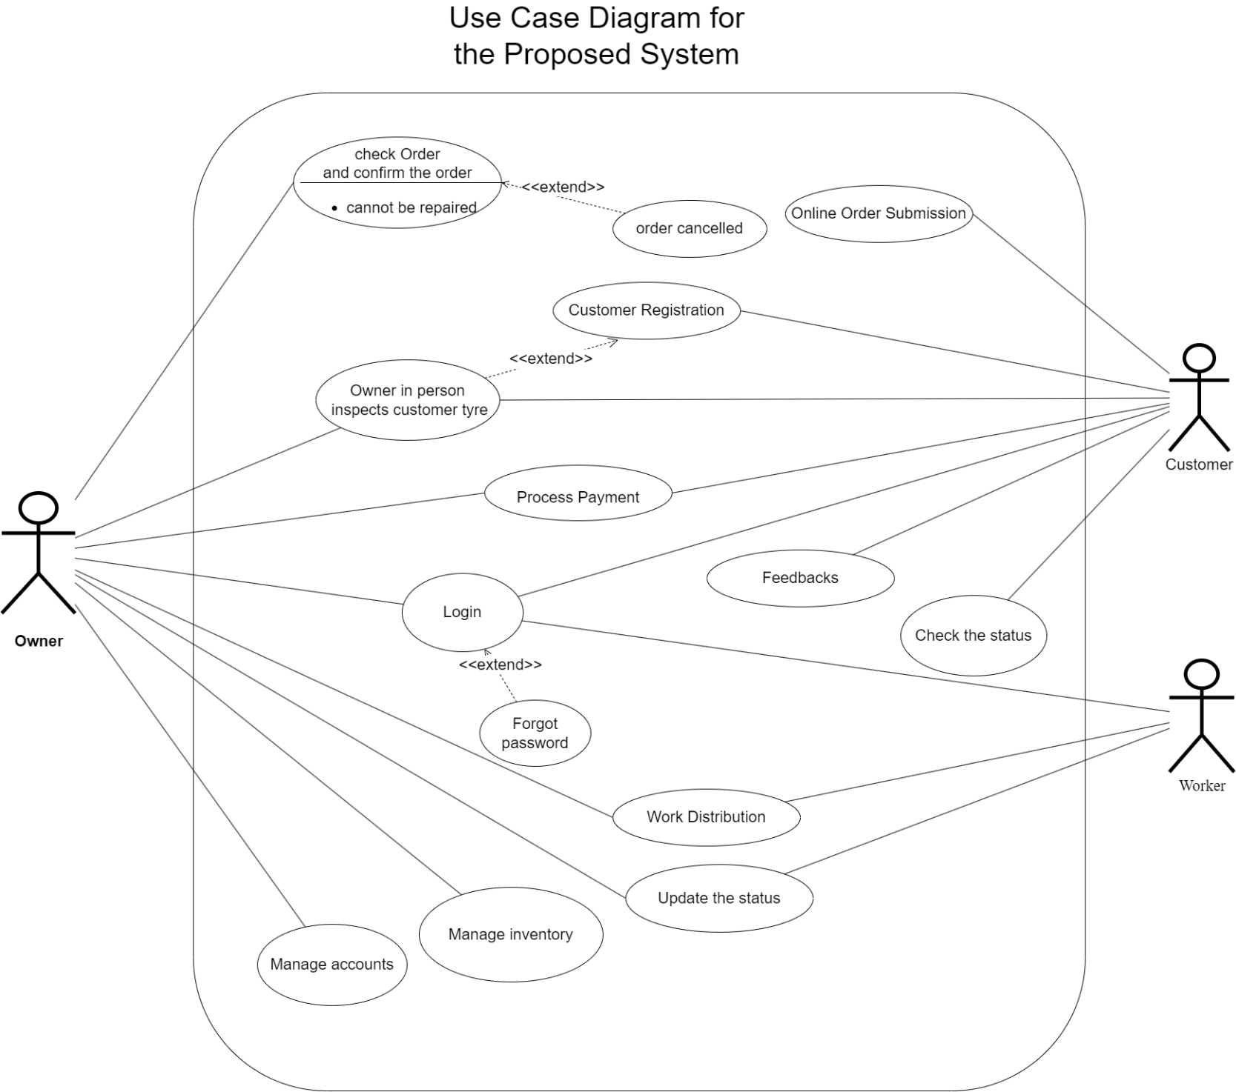

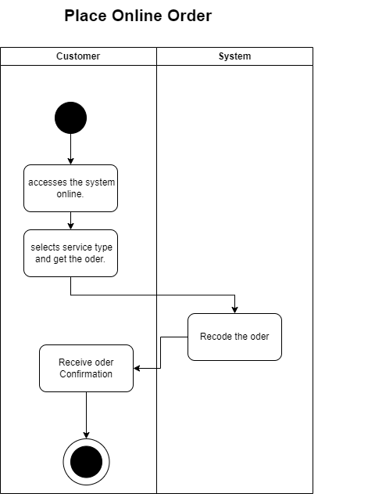

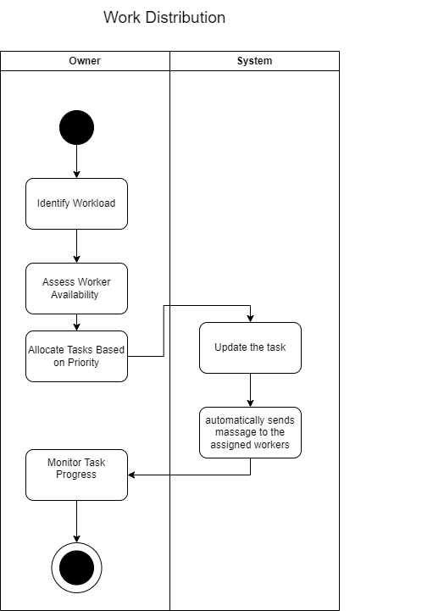

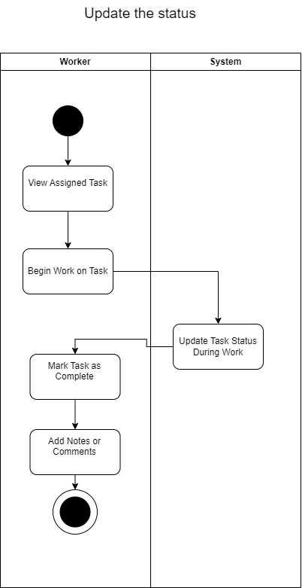

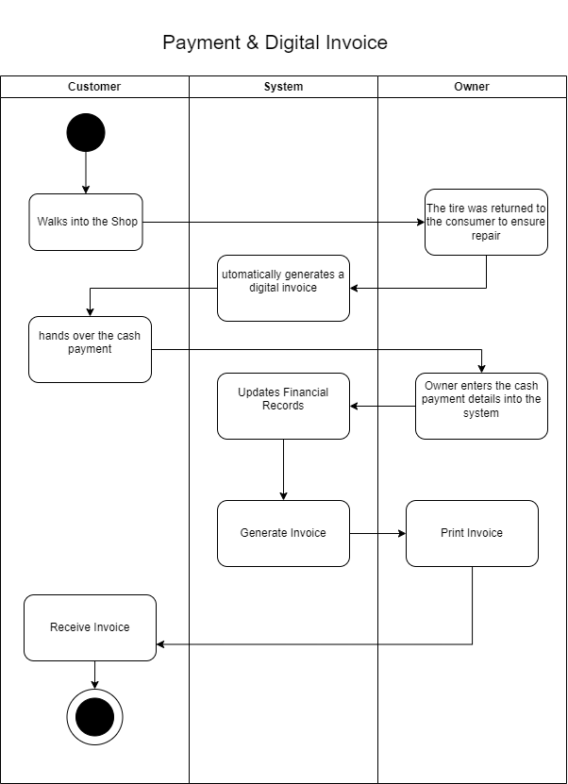

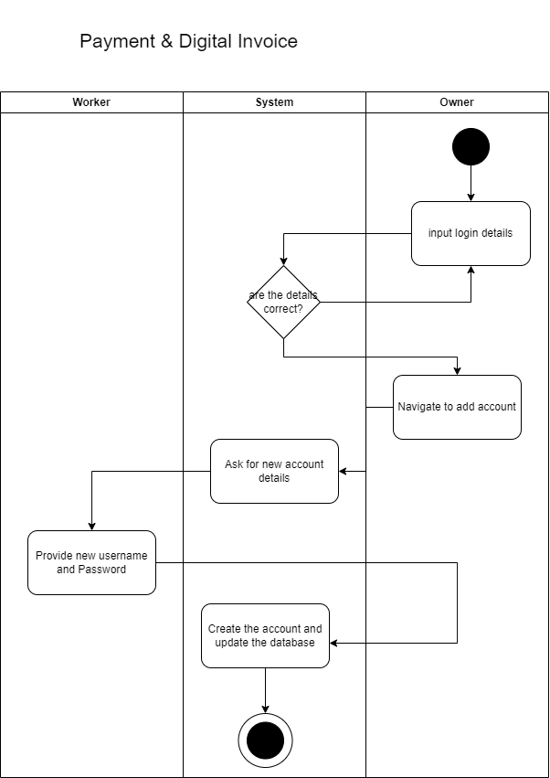Manage accounts

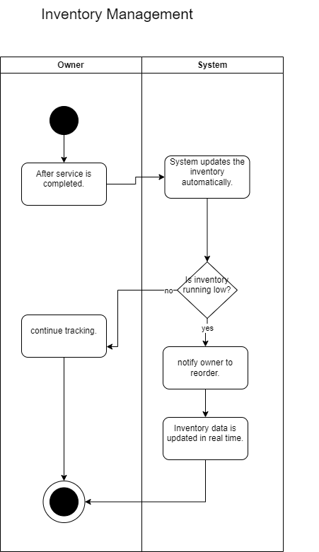

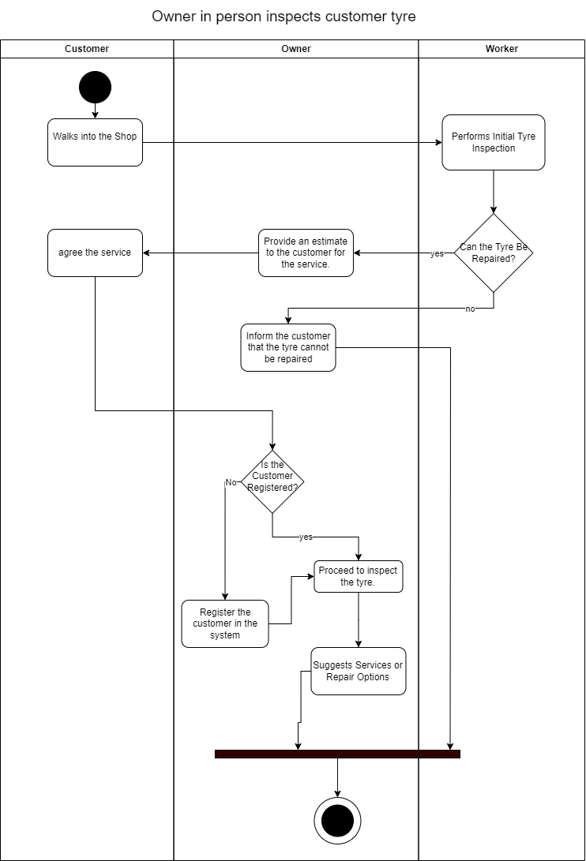

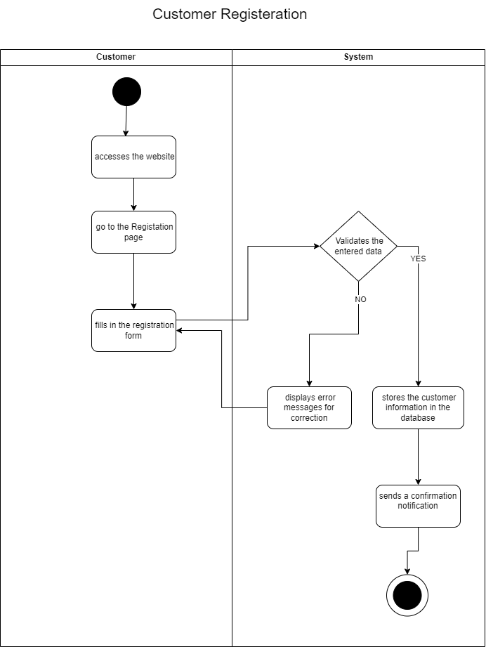

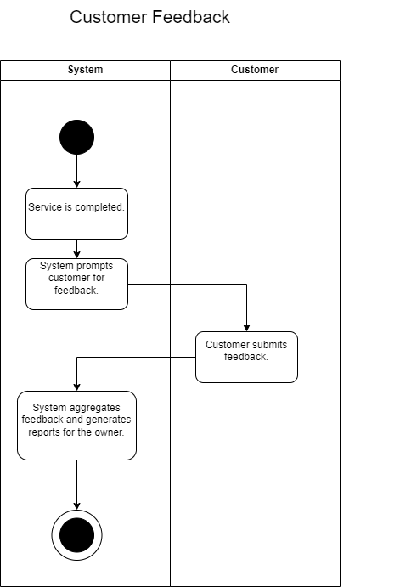

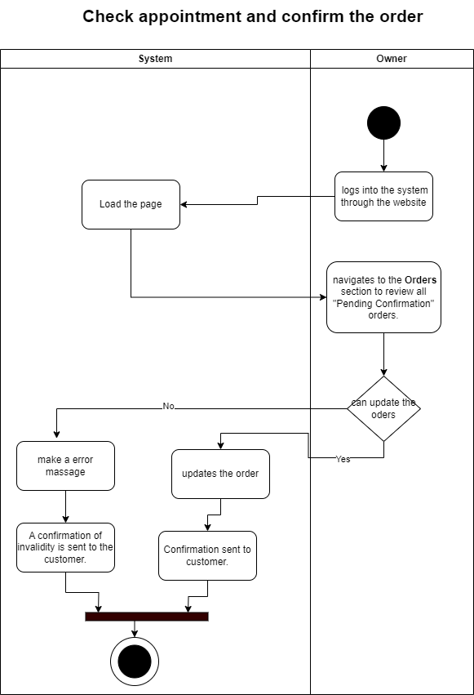

**ER Diagram**

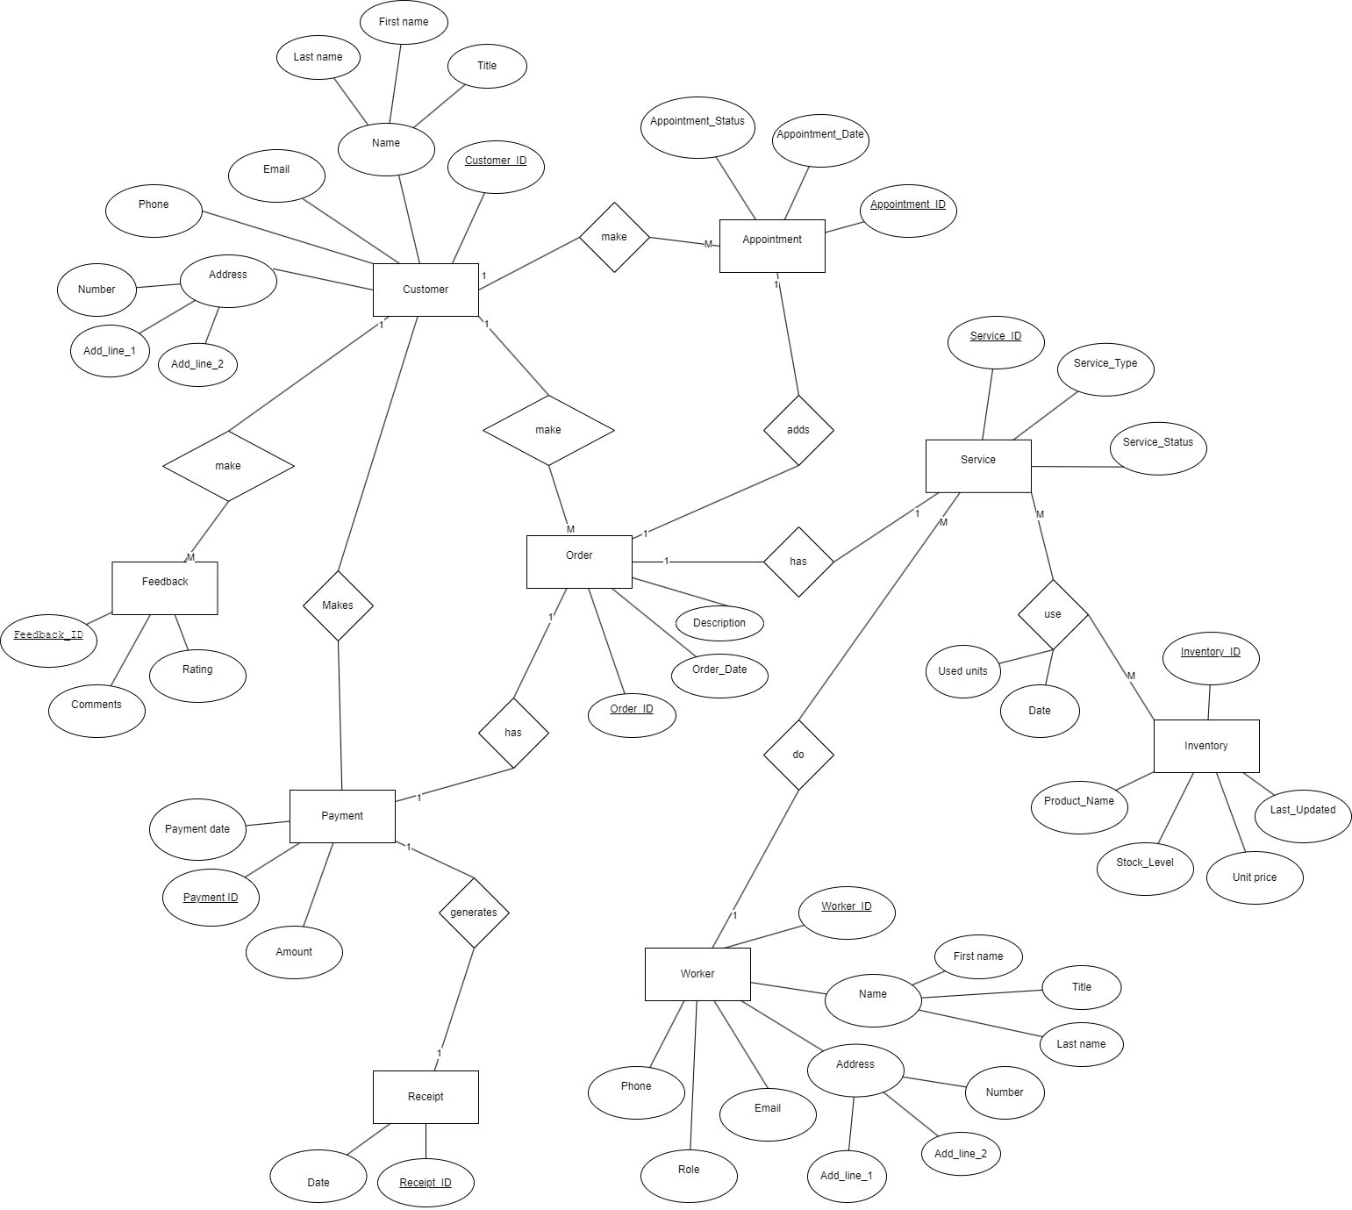

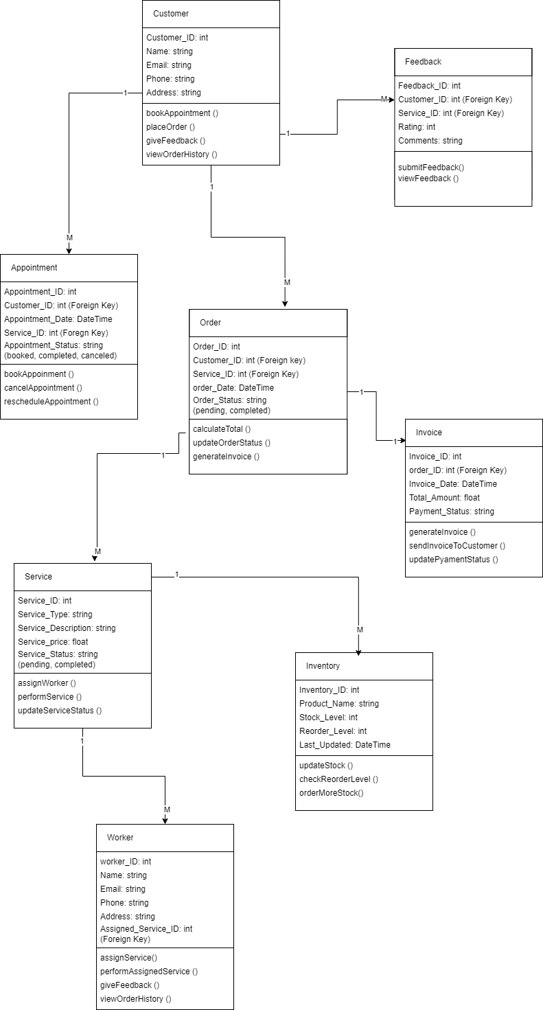**Class Diagram**

**Relational schema**

**Customer** (Customer_ID, Title, FirstName, LastName, Email, Phone, House_no, Address_line_1, Address_line_2, username, password)

**Order** (Order_ID, Order_Date, Order_status, TotalAmount, *Customer_ID)

**Service** (Service_ID, Service_Type, Tyre_Structure, Size_code, Preferred_completion_Date, Service_Status, Tyre_Brand_Name, *Employee_ID)

**Inventory** (Inventory_ID, Product_Name, Stock_Lavel, Unit_price, Last_updated)

**Appointment (**Appointment_ID, Appointment_Date, Appointment_Time, Status, *Customer_ID)

**Employee** (Employee_ID, Title, First_Name, Last_Name, *Service_ID)

**Worker (**Worker_ID, Phone, Email, Assigned_Service_ID, House_no, Address_line_1, Address_line_2, username, password**)**

**Owner (**Owner_ID,username, password, secret_key**)**

**Payment** (Payment_ID, Amount, Payment_Date, Payment_Time)

**Feedback** (Feedback_ID, Rating, Comments, *Customer_ID)

**Receipt** (Invoice_ID, Invoice_Date, Total_Amount, Payment_Status)

**Repair** (Puncture Size, Number of Patches Applied, Repair_your_tyre_photos)

**Retreading** (Tire Width, Wheel Diameter, Tyer_Pattern, Image_URL)

**Inventory_Service (**(Inventory_ID, Service_ID, Used units, Date**)**

**Retreading _Image_URL (**Service_ID, Image URL**)**

**Repair_** **Repair_your_tyre_photos (**Service_ID, Repair_your_tyre_photos**)**

**Customer_Phone (**Customer_ID, Phone**)**

**Worker_Phone (**Worker_ID, Phone**)**

## Sequence Diagram

### Login

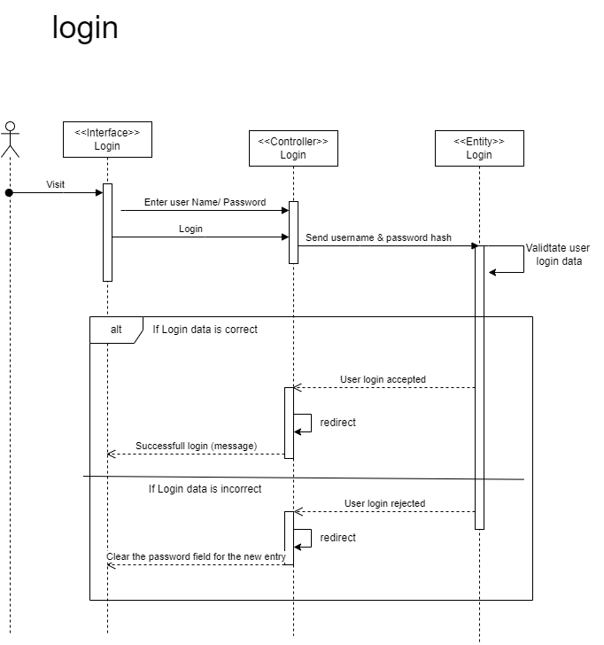

### Create Account

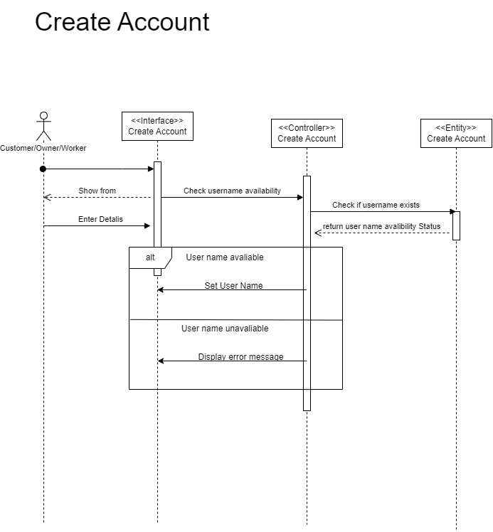

### Place Order

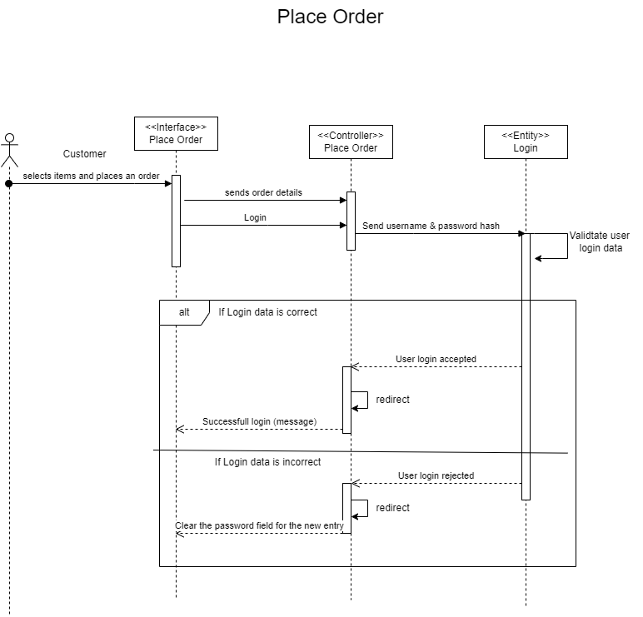

### Work Distribution

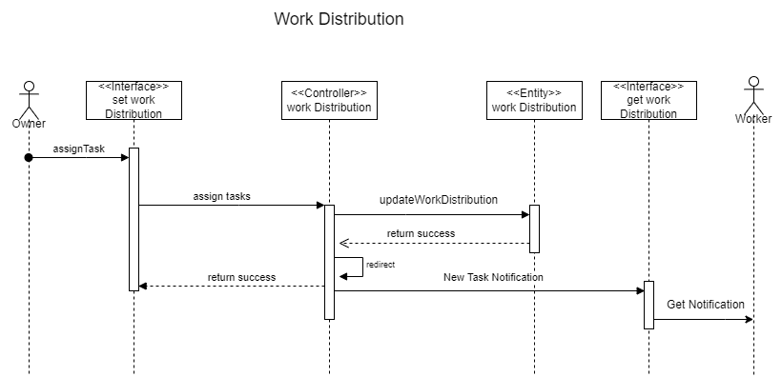

### Owner Inspects Customer Tyre [in place]

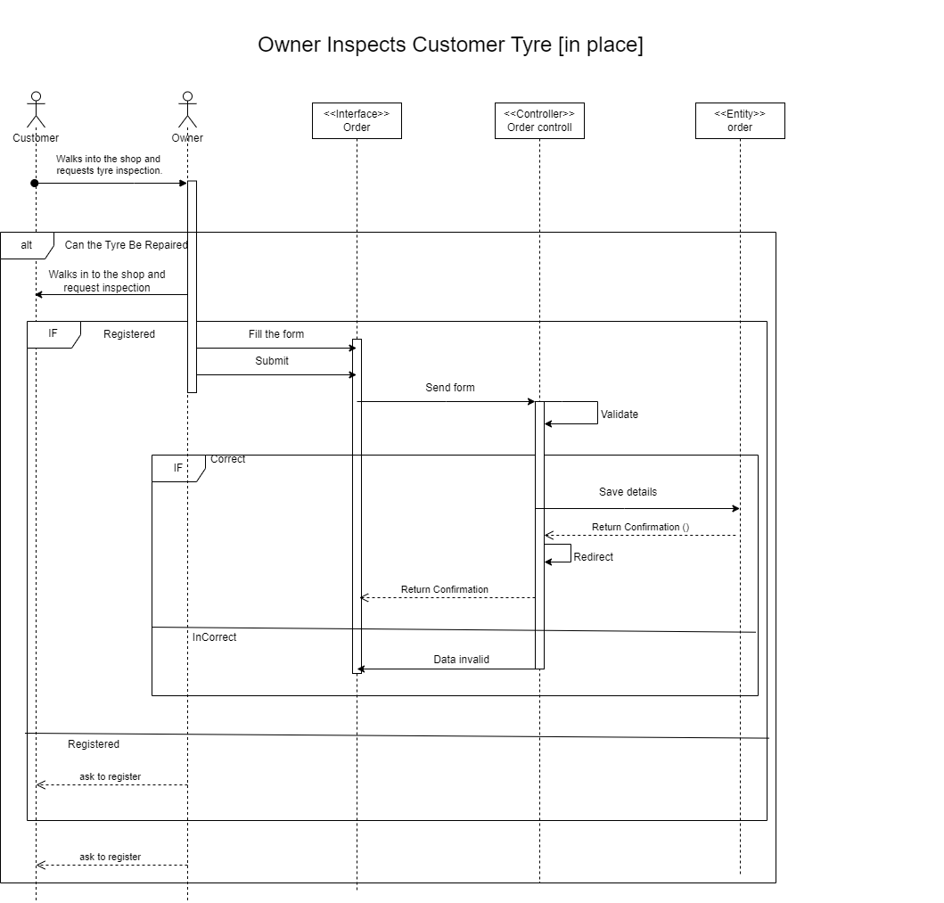

### Payment & Digital Invoice

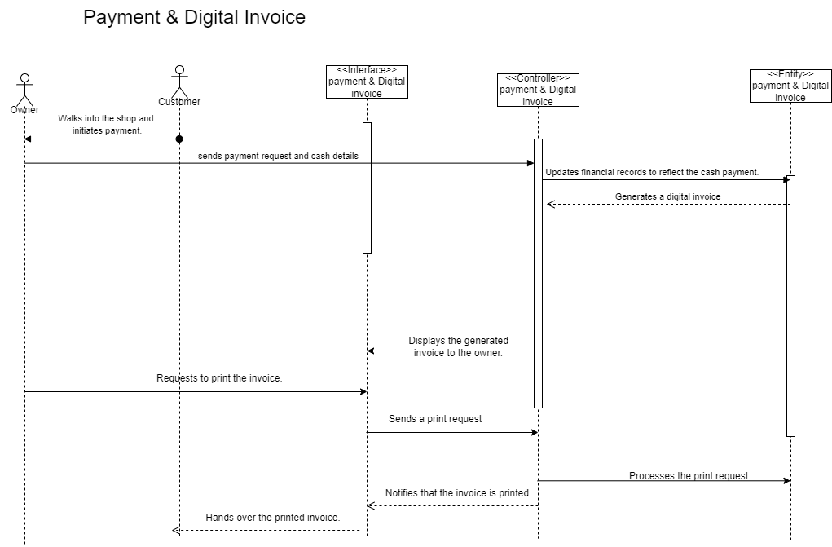

### Customer Feedback

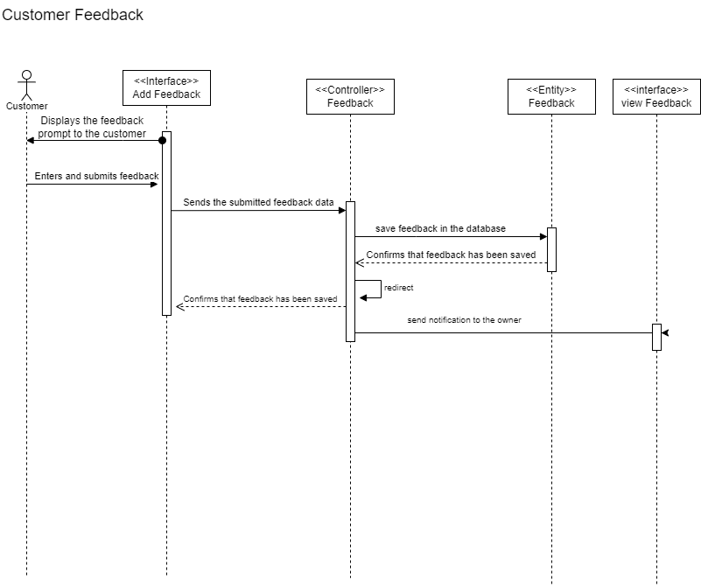

### Inventory Management

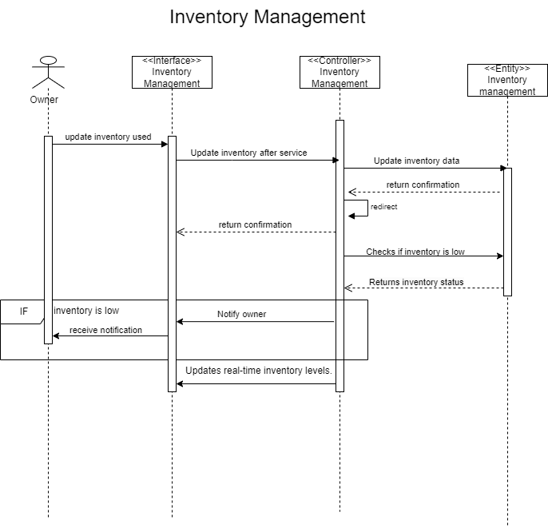

### Manage Account

